EUROĽEAN UNION ĽUDLII HEALľH AND
poses a unique challenge for the Western Balkan states, where local health policies are not in line with EU standards and strategies regarding public health and the protection of migrant health.

The summer school aims to give a basic
Cultural approaches to vulnerable groups: This topic will examine how cultural factors influence the health and well-being of vulnerable groups, including migrants, and explore culturally sensitive approaches to address their specific healthcare needs.

Sarajevo

MICRAľIONC
introduction to the subject by featuring lectures from renowned experts. It will focus on various techniques to examine, interpret, and disprove the topic such as professional and media cover- age of the new challenges presented with the
EU public health and debates on
migrant standards: The session will focus on current debates surrounding the application of public health standards to migrants within the European Union, discussing the implications,

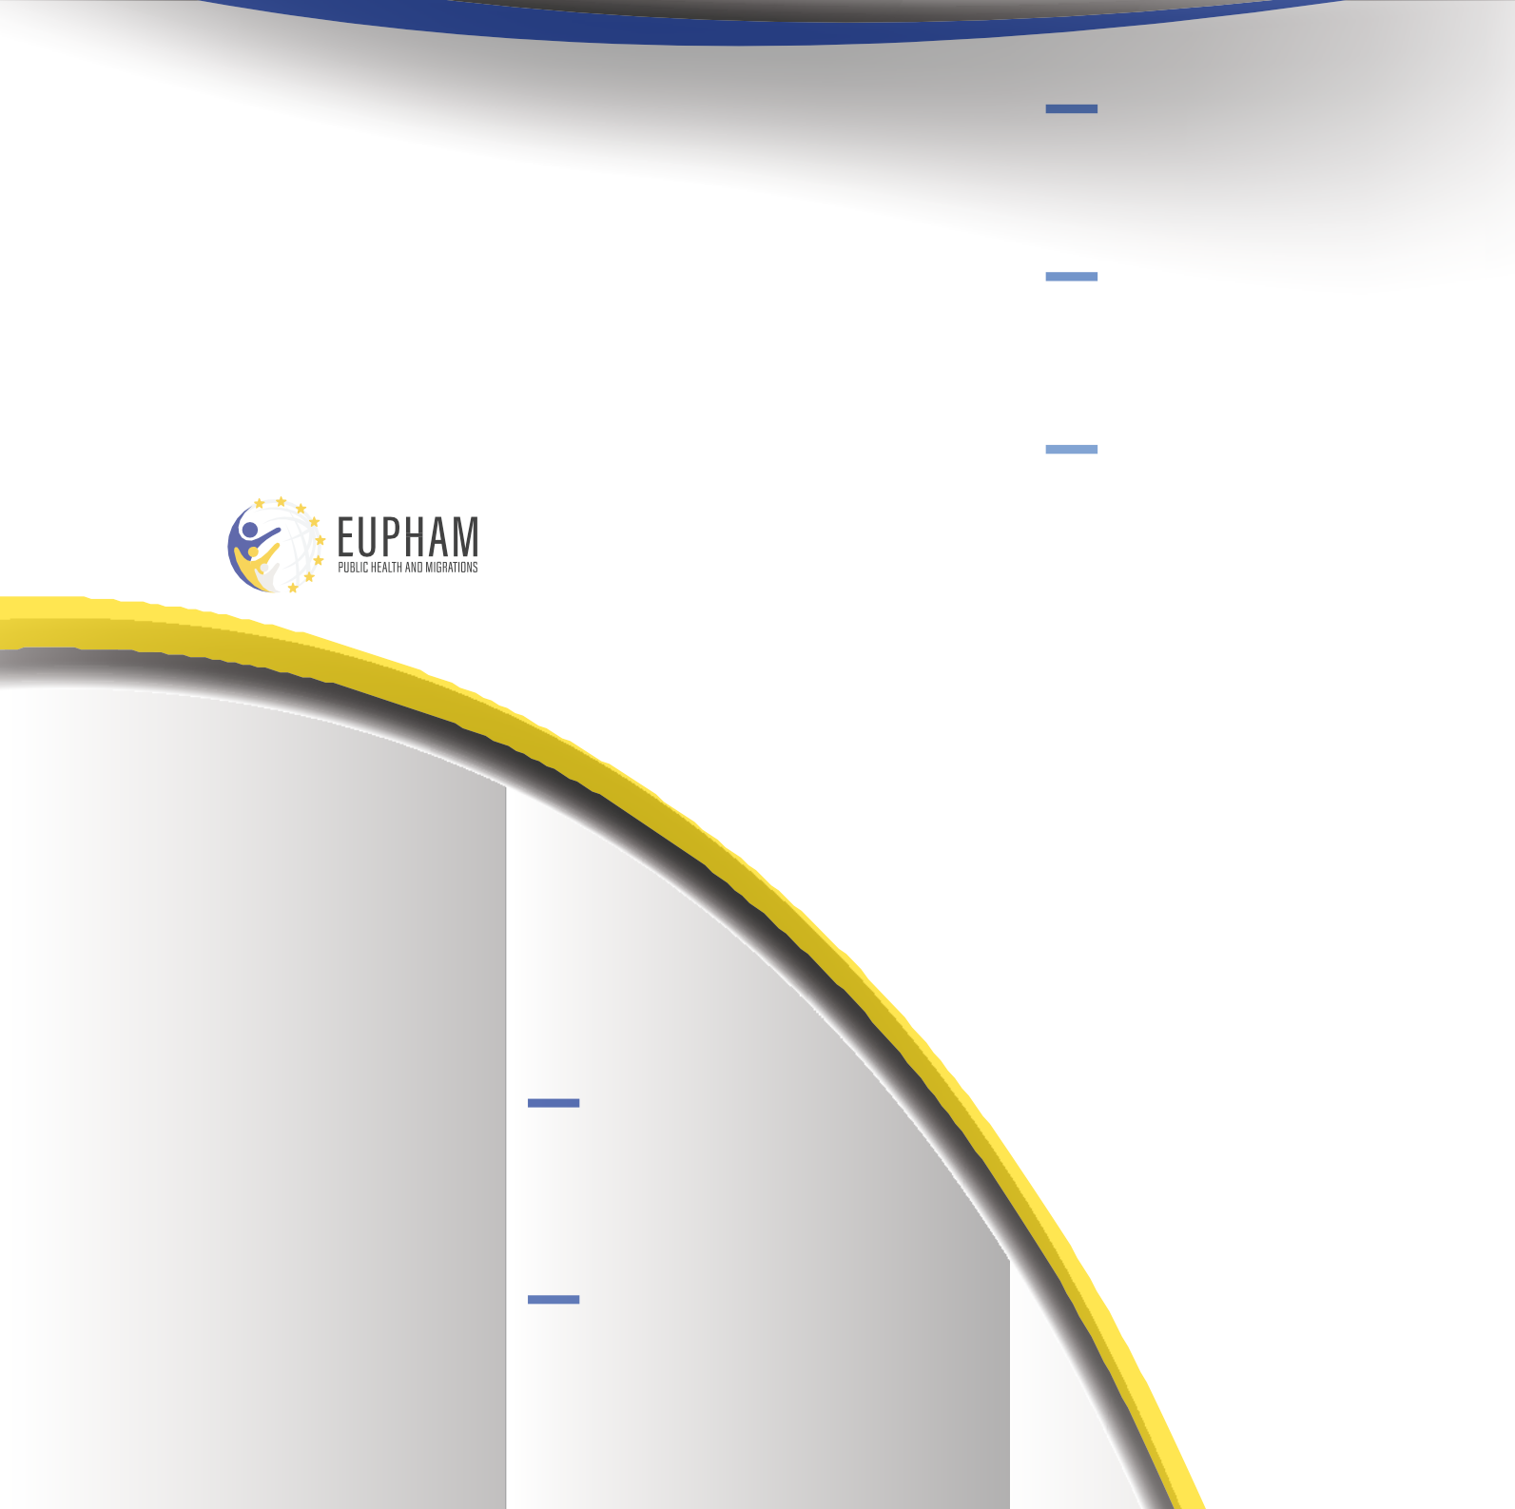
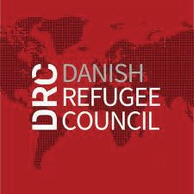
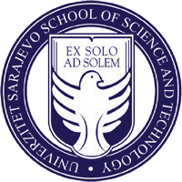
Bosnia and Herzegovina
11-15 September, 2023
Se

The Sarajevo School of Science and Technology, in collaboration with the Danish Refugee Council (DRC) is proud to announce the second Summer School on EU Public Health and Migrations. This event is being conducted under the Jean Monnet Module on EU Public Health and Migrations (EUPHAM). The summer school will specifically address the challenges and experiences faced by migrants traveling along the Balkan Route.

IOURCE DECIRIĽľION
The EUPHAM module is a highly specialized training course focused on EU public health during a time of heightened global public health risks and migration crises. As migration patterns change, there are significant impacts on the physical and mental well-being of both migrants and the host or transit countries. The presence of a migration crisis can particularly affect local public health policies in cases where a specific country lacks integrated public health measures that align with EU standards. Addressing these inconsistencies
migration crisis and Covid-19 pandemic in terms of offering knowledge on EU health policy standards and their specific application and meaning for migrants’ health protection in the European Union. It will also address importance of universal health care for migrants with focus on evidence-based and inclusive policies.

ľEAIHINC MEľHODC
The Summer School will provide a total of 30 hours of classes, which will be conducted
over the course of 5 days. The venue for the event will be the Sarajevo School of Science and Technol-
ogy in Sarajevo.

THE LECTURES AND FIELD
TRIPS DURING THE SUMMER SCHOOL WILL ENCOMPASS A WIDE RANGE OF TOPICS, INCLUDING:

Public health in the EU and Western Balkans: This session will explore the public health systems and policies in both the European Union and the Western Balkans, highlighting similarities,
differences, and potential areas for collabora- tion.

Communicable diseases: Participants will delve into the challenges posed by communi- cable diseases in the context of migration and explore strategies for prevention, control, and treatment.
challenges, and potential solutions.

E-health and EU practices: Partici- pants will explore the role of e-health in promoting public health and healthcare delivery within the EU context, examining best practices and innovative approaches.

Through these lectures and field trips, partici- pants will gain comprehensive insights into various aspects of public health, migration, and EU policies, fostering a deeper understanding of the subject matter.

The programme of the summer school will be sent to accepted students prior to the beginning of the school.

PARTICIPATION FEE

The participation fee for the Summer School is 25 Euros for students and 35 Euros for all other participants. This fee includes one lunch and one coffee break per day, tuition for the program, confer- ence materials, and field trips in and around the city of Sarajevo. By covering these costs, the fee ensures that partici- pants have access to necessary amenities and resources throughout the duration of the Summer School.

Please send the completed application form with a letter of intent no later than
September 8, 2023 at 23:59 to info@eupham.org

