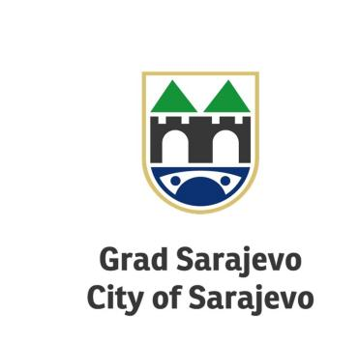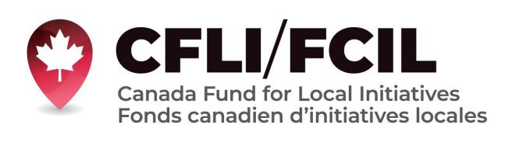

The City of Sarajevo is actively working on strenghtening position of women in our community.

The City of Sarajevo with the support of th Canadian Fund for Local Initiative (CFLI), begins the implementation of The ACCESS project - ACCess to rights for women through information about and engegement with authorities in the City of Sarajevo and its Municipilities - ACCESS.
The project will be implemented in The City of Sarajevo and its four Minucipalities. Through the project are planned workshops, conferences, and open days in the municipalities, all in the next six months, ending in February 2023.
The goal of the project is to empower and enable easier access for women to their rights, through the cooperation of local authotities, civil society and citizens.
Mutual understanding and cooperation between local authorities in the Sarajevo and their municipalities, and the community as a whole, threough project activities will be strengthened.

We are greateful for Canada’s contribution to this project through the Canada Fund for Local Initiatives.

Disclaimer: The opinions contained in this publicitation do not necessarily riflects those of Government of Canada

