Welcome…

We are looking forward to see you from 16 December to 23 December in Sarajevo, Bosnia an Herzegovina.

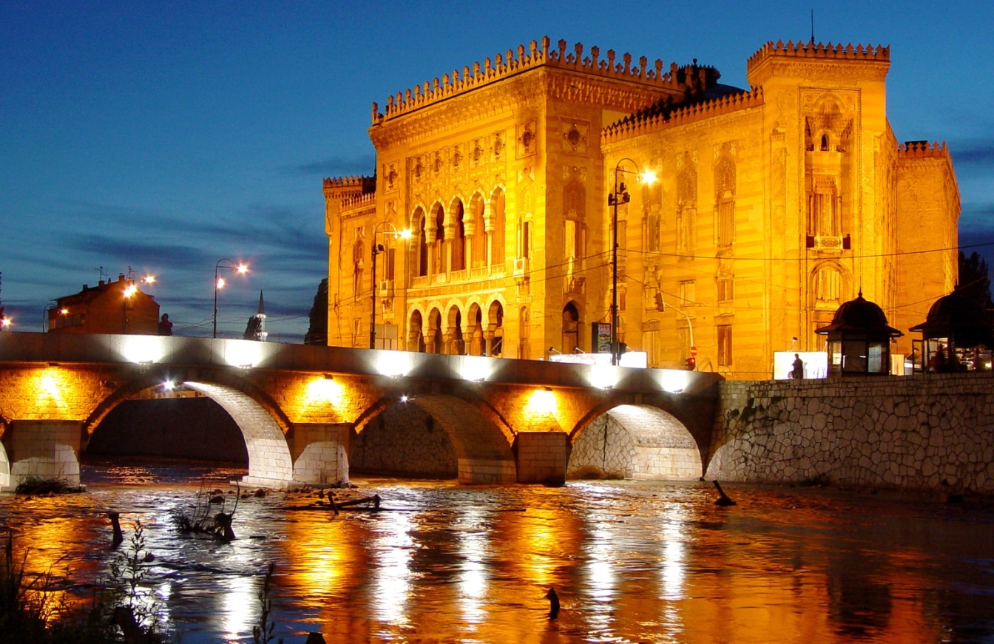

But before you come in the town of warm souls, there is still a lot to do. To make this project successful and in wish to help you, we prepared this information guide. Here you can find all important informations you need for your preparation.

Key Action 2,
Capacity Building for Youth in neighboring and enlargement countries

„Volunteering connecting communities“

INFO ABOUT PROJECT:
Volunteering connecting communities (VCC) is a project which involve 500 youth workers, 5 organizations and over 2500 young people (members/activists/young people of whole consortium) to get empowered through information and concrete tools in voluntaryism and inclusion topic in local and international level. All partners will get equally involved and share responsibilities and tasks in series of activities planned in local and international level regarding preparation, implementation and dissemination of the results. This project aims at increasing youth potential in civic education and especially volunteerism topic through capacity building actions targeting youth workers who work with young people with fewer opportunities in local and European level. The project aims as well to increase the quality of youth work through exchanging of experiences and building up sustainable partnership among partners of the consortium and other NGO-s and institutions in respective countries.
The activities of the project will consist on different Meetings, info sessions, seminars, training. In international projects, the methodology of the project will be mainly based in non formal education approach. Concrete methods to be used are: brainstorming, role plays, simulation exercises, debate, open group discussion, questions and answers, theatre, buzz groups, presentation of short videos, collage, creative workshops etc.
The objectives:
- Promote volunteerism as an added value of the European societies and a form of active participation targeting youth with fewer opportunities
-Improve competencies of Youth workers in training approach in order to add quality to youth work
- Improving quality of information exchange through peer to peer education especially working with young people with fewer opportunities
- Share the best practices and know-how among the consortium
- Equip participants with expertise on effective and efficient volunteer management programs tailored for the community needs
- Promote Erasmus + among networks in Western Balkans and Europe
- Forster a stronger partnership among the selected partners that shall establish closer cooperation bridges for the long term
- To boost the creation and development of innovative projects/modules and activities in youth field focused in young people with fewer opportunities
-Present the Structured Volunteerism Technique as innovative and add quality in youth work

Activity 2. 16-24 December 2019, Sarajevo, B&H. Seminar on volunteering, unemployment and European volunteering to discuss for tendency, problems, needs and opportunities for young people.

INFO ABOUT ACTIVITY:

A mixture of themes will be combined to be discussed among youth workers about the concept of volunteerism and its associated concepts such as: volunteerism and youth work, youth participation and opportunities for empowerment of youngsters in professional and social level, employment and life skills, volunteering as an approach for community building, solidarity and social cohesion. Participants will prepare national presentations of the state of volunteerism in each country, discuss, share ideas, best experiences, challenges met in everyday work regarding volunteer work and provide suggestions how to improve volunteer work. Participants will discuss about youth unemployment especially related with young people with fewer opportunities in local level and provide suggestions and solution making the link with volunteerism and opportunities it offers as a response to youth unemployment in national and European level. Different strategies in European level to be applied in national level about volunteerism and solidarity, employment of young people will be discussed. Structure of the Volunteer Hub and activities to be developed in local level will be elaborated during the seminar. The learning outcomes of the seminar will be collected by the reporter and will be spread to different stakeholder in local, national and European level.

PARTICIPATION FORM:

Please contact your organization then fill in the participation form.

REIMBURSEMENT:

Reimbursement limits per country, we will receive a certain amount of money for this purpose, by regarding Erasmus+ Program rules we need to follow certain administrative procedures.
Save your original tickets and receipts, invoices and all related documents, because you can only get reimbursement for costs of which you can prove the amounts with original tickets and receipts. Only the amount written on the ticket will be reimburse.

COUNTRY | NAME OF ORGANIZATION | NUMBER OF PARTICIPANTS | TRAVEL COST (EUR)
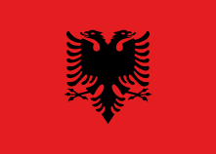Albania | BBA | 4 youth workers | 180 per participant,
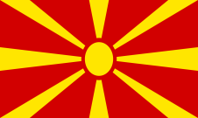  Macedonia | VCC | 5 youth workers | 180 per participant,
Romania | Asociatia Allons-y | 4 youth workers | 180 per participant,
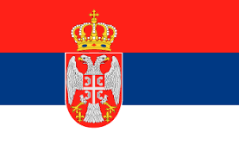  Serbia | IUVENTA | 4 youth workers | 180 per participant,

WHAT TO BRING?

-Ideas, motivation and smile
-Warm clothes (it may rain and windy)
-Sunglasses (it may sunny)
-Personal medication
-Bring something what represents your country for intercultural nights. Food, drinks, music, dance and material to represent country you are coming from.
-Don't forget to bring informations about your organizations

Most important! Before coming participants has to do:

-PRESENTATION ABOUT EACH COUNTRY FOR TOPIC OF OUR PROJECT;
-BEST PRACTICES FROM EACH SENDING ORGANISATION OR OTHER ACTORAS IN LOCAL LEVEL IN ORDER TO SHARE IT WITH OTHER PARTICIPANTS FROM EUROPEAN COUNTRIES

ACCOMODATION:

- Arrival day is the 16 December and Departure day is the 23 December.
- Accommodation will be located in “Braca Mujic'' hotel- Sarajevo (http://hotelibm.com/hbm/)

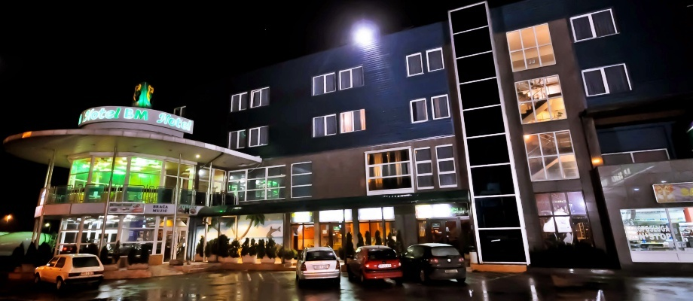

- All participants will be accommodated in shared bedrooms (2, 3 or 4). In the room there is a toilet, bathroom, TV, towel, hair-dryer and air-conditioner .
- Please bring your own Slipper/sandal and there is free wifi-connection on the venue.

TRANSPORTATION:
We will organize transportation from airport, train and bus station.
Before your trip, or during the trip, you have to contact us, and let us know in what time you will come here, so that we can organize transportation.
DIRECTOR:
Belmin Debelac
Email: belmin.debelac@gmail.com
Phone: +38761757604

EMERGENCY PHONE NUMBERS
Police: 112
Fire department: 123
Ambulance: 124

