******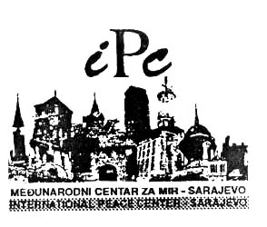**



**INVITATION**

**To the XXXV International Festival Sarajevo**

**“Sarajevo Winter 2019”- BUKA I BIJES – NOISE AND FURY**

**February 7 – March 21, 2019**

**Dear Sir/Madam,**

**International Festival Sarajevo “Sarajevo Winter” has a pleasure of inviting you to be part of this prestigious Festival.**

International Festival Sarajevo – “Sarajevo Winter”– is a traditional cultural and artistic event which takes place in Sarajevo, the capital of Bosnia and Herzegovina. This year’s Festival will be held under the motto “**BUKA I BIJES NOISE AND FURY**

The XXXV International Festival Sarajevo “Sarajevo Winter 2019” will, as every year, represent an encounter of artists from all over the world. The International Peace Centre Sarajevo is the organizer of the Festival.

The programme for this year’s edition consists of Theatre plays, Concerts, Movies, Fine Arts Exhibitions, Panel Discussions, Literary Events, Architecture, Video, Programmes presenting cultural heritage, and Children Programmes.

The programmes of the Festival will be held in theatres, galleries, museums and concert halls in the city, as well as on the Olympic mountains during the Festival, and within the Opening and Closing Ceremony.

The Festival is honoured to invite you to Sarajevo **to perform your performance** as part of the programmes for the following edition of the Sarajevo Winter Festival. Please note that Festival bears the expenses of accommodation with breakfast, local transport, as well as media promotion of artists.

For any additional information do not hesitate to contact us:

With deep respect,

Ibrahim Spahić

Director of the International Festival,

Sarajevo “Sarajevo Winter”

## CONTACT ADDRESS

1. International Peace Center / Internacional Festival Sarajevo ”Sarajevo Winter”
2. Titova 9a/V; 71000 Sarajevo, Bosnia and Herzegovina
3. Cell: 0038762031594;
4. e-mail: [sarajevowinter2018@gmail.com](mailto:sarajevowinter2018@gmail.com),
5. www.[sarajevskazima.](mailto:sarajevskazima2017@gmail.com)ba
6. www.ipcsa.ba